WorkFlow of the assignment

**SASS Modifications:**

1. Before: The menu items were white and on mouse hover they turn yellow.

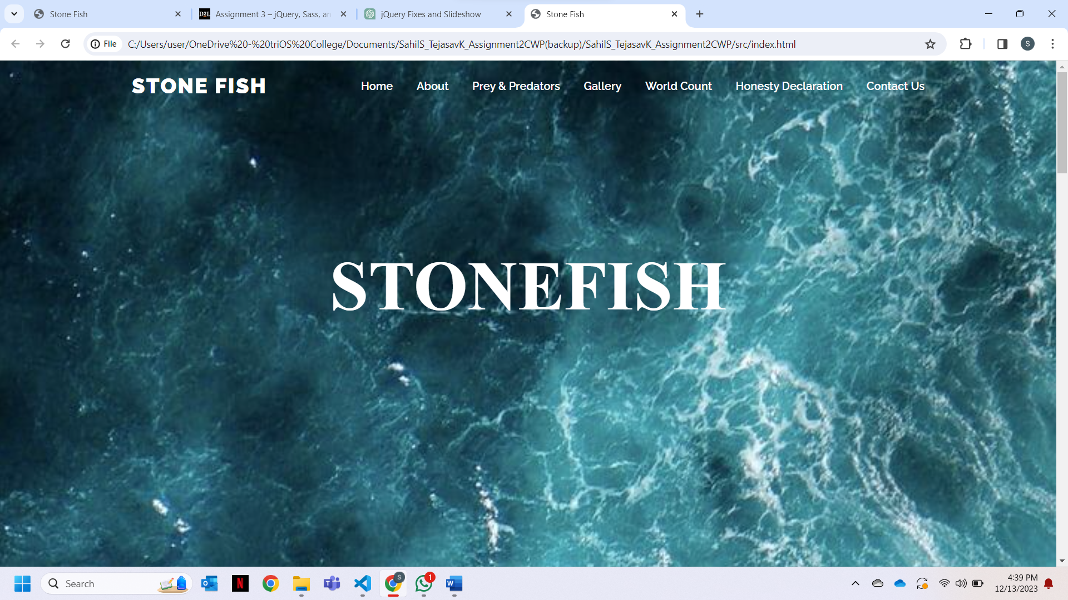

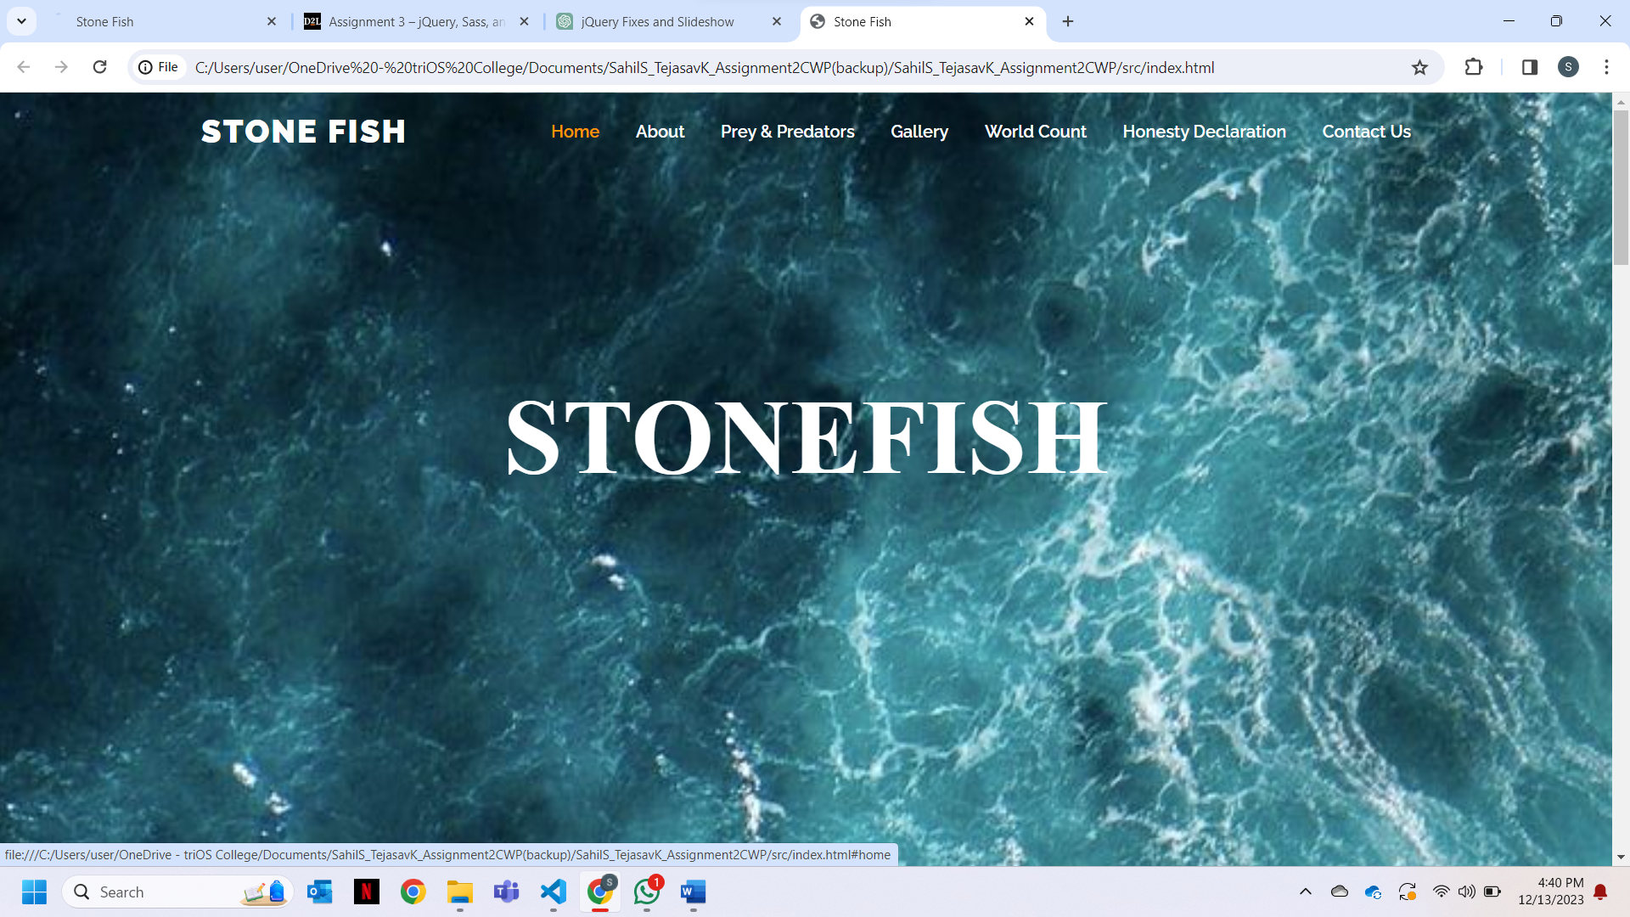

After: The menu items were made yellow and on mouse hover they turned white

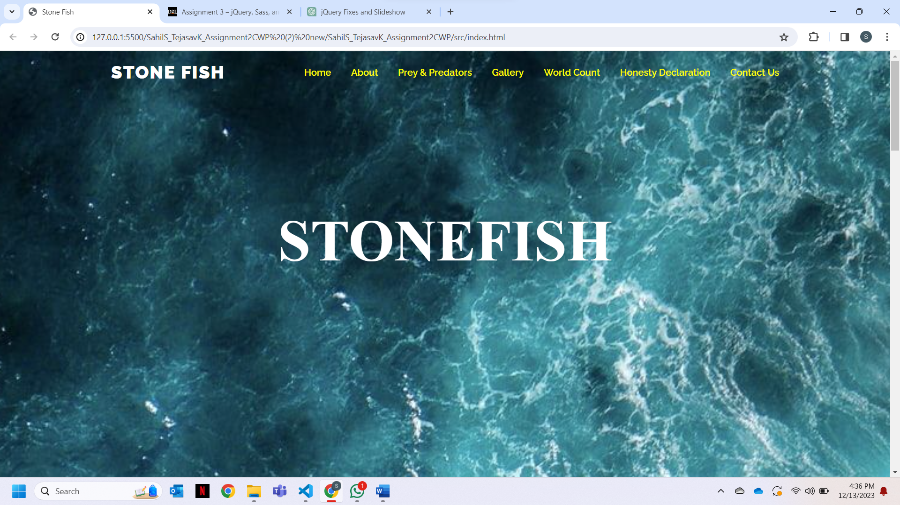

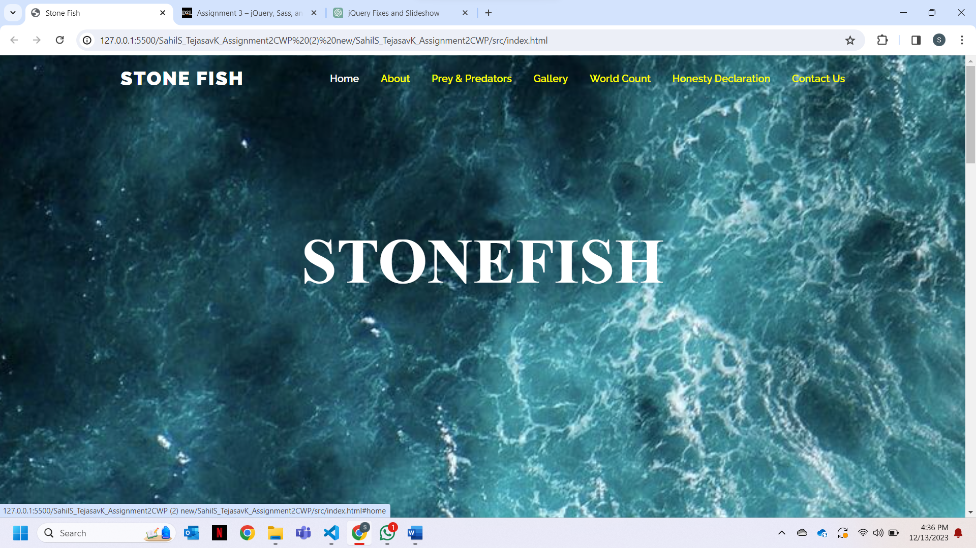

1. Before: The sign up from had simple solid border.

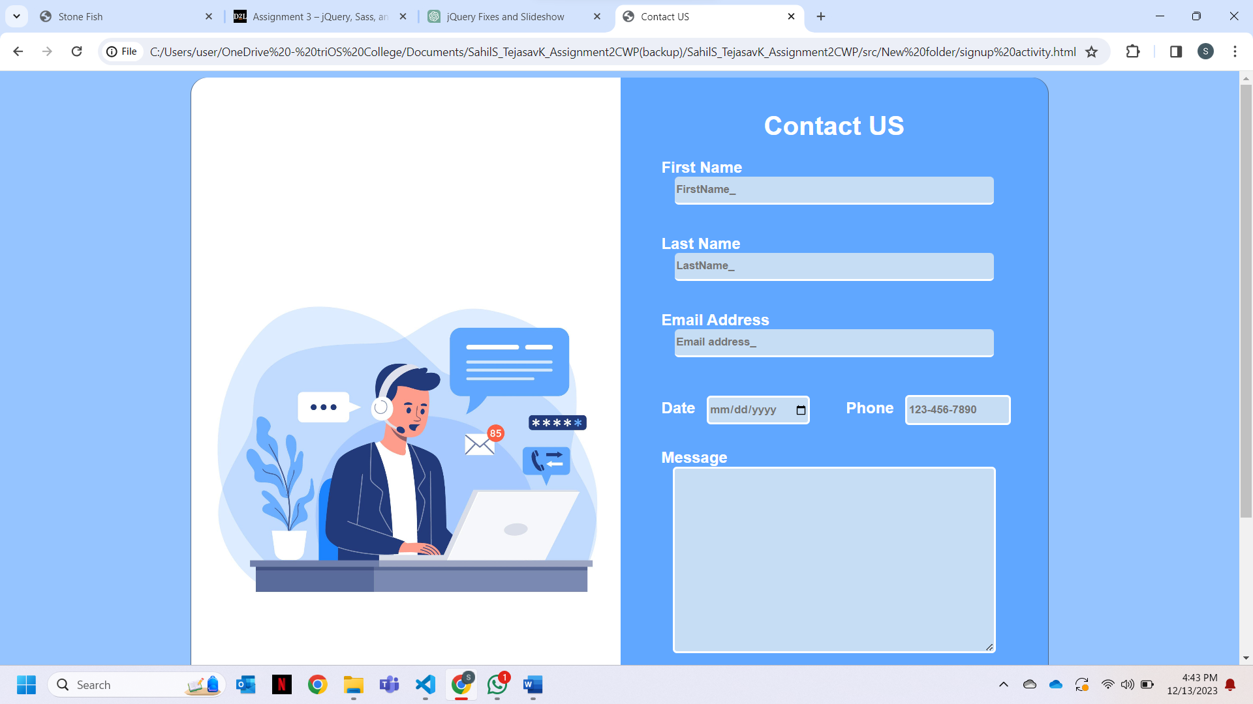

After: The from had dashed border.

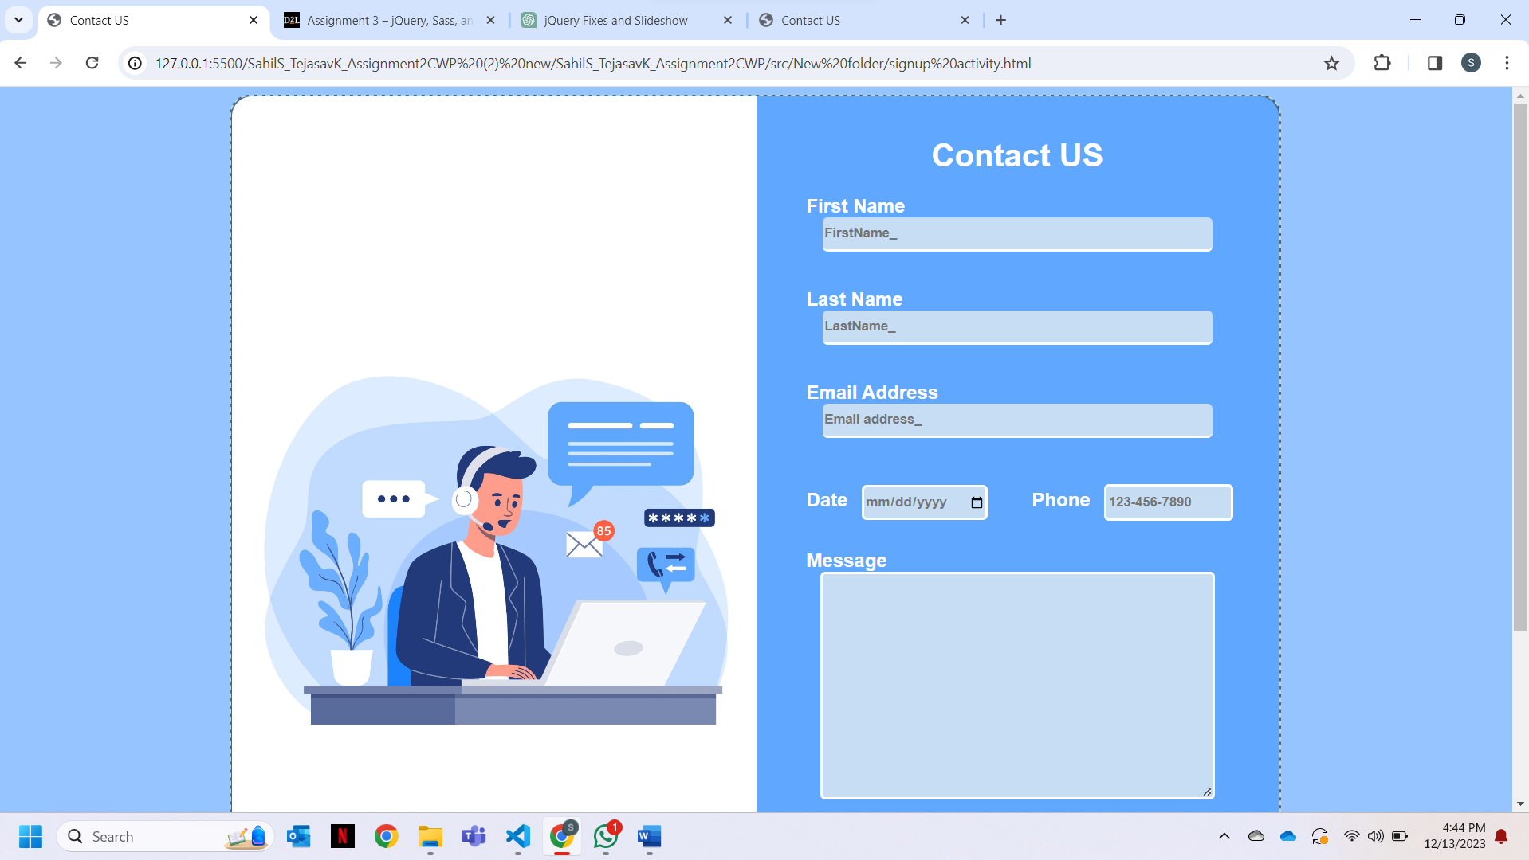

1. Before: the colour of the button was not blue.

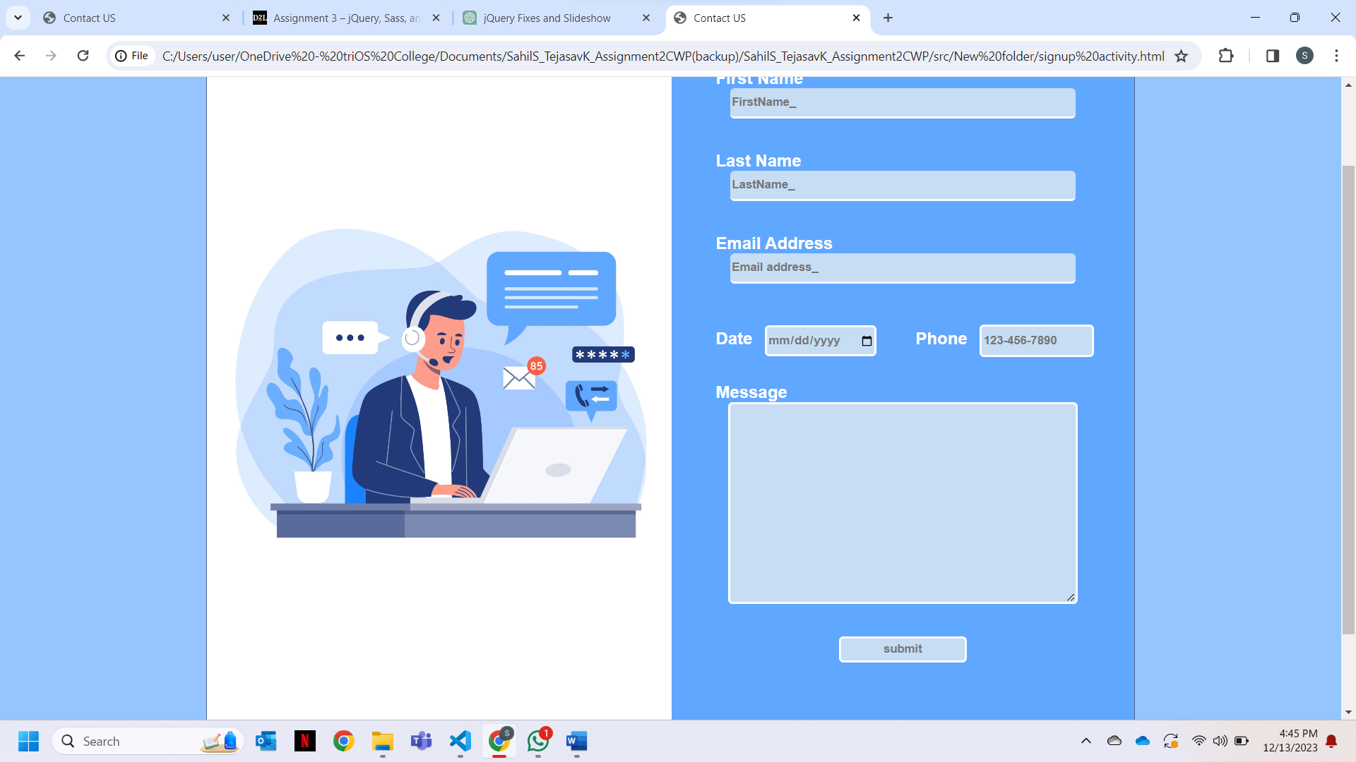

After: The background color the button was changed to blue.

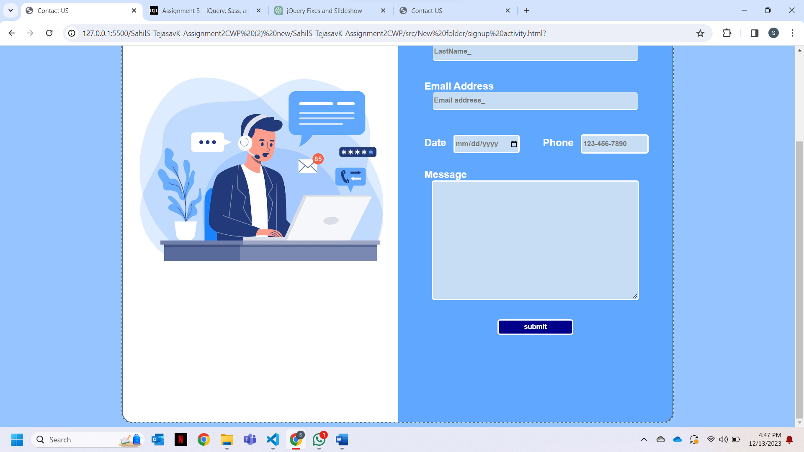

**JQuery Modifications:**

1. Before: The nav bar was not fixed.

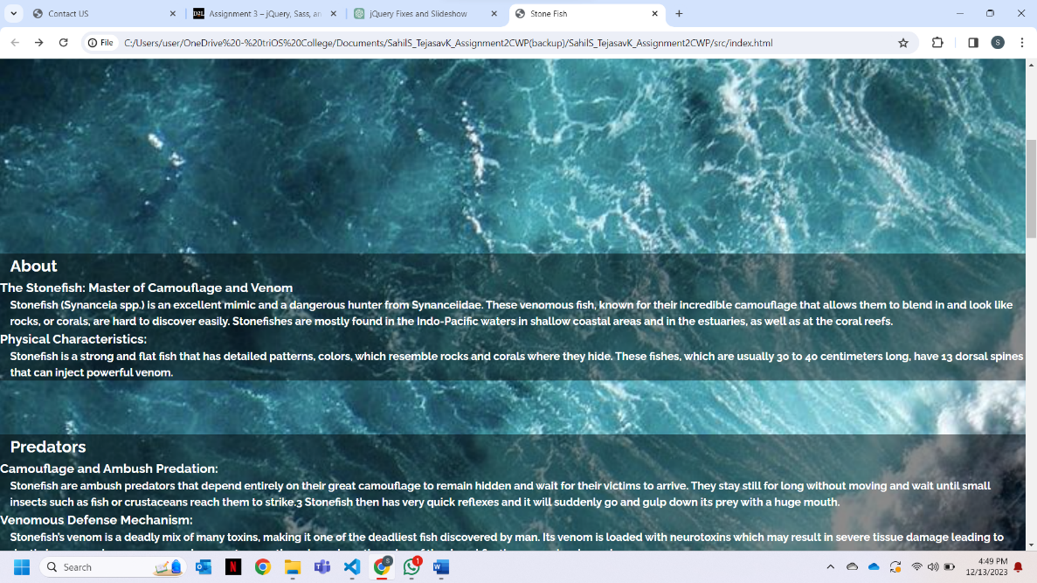

After: The nav bar was made fixed.

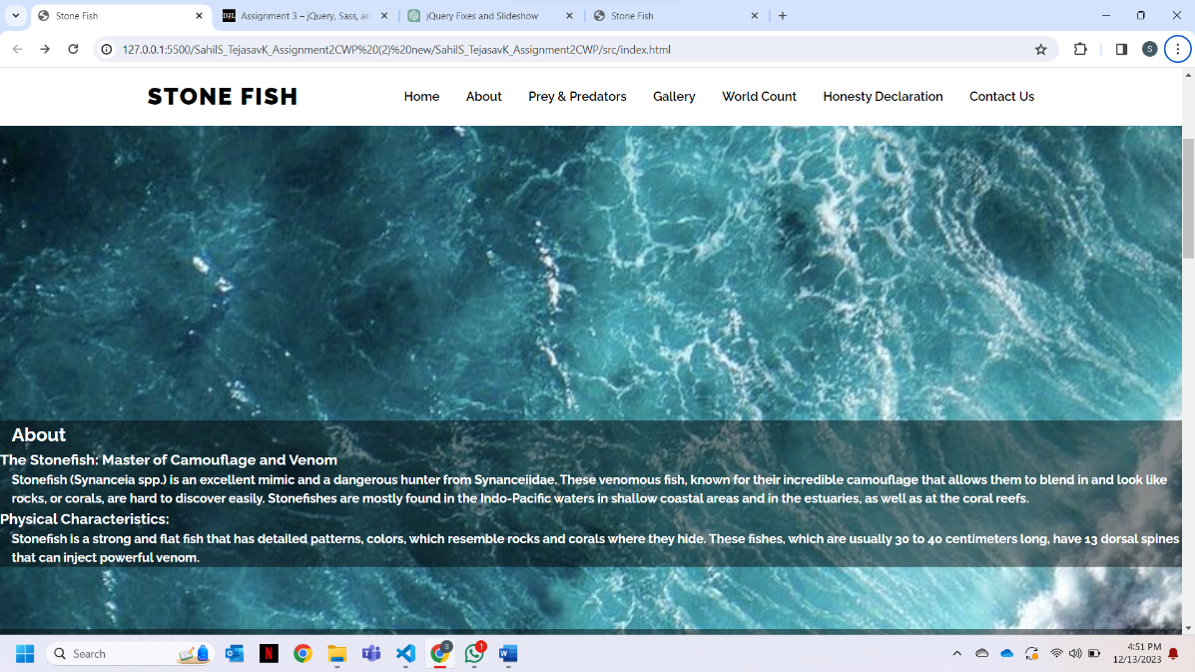

1. Before: The images were displayed as a gallery.

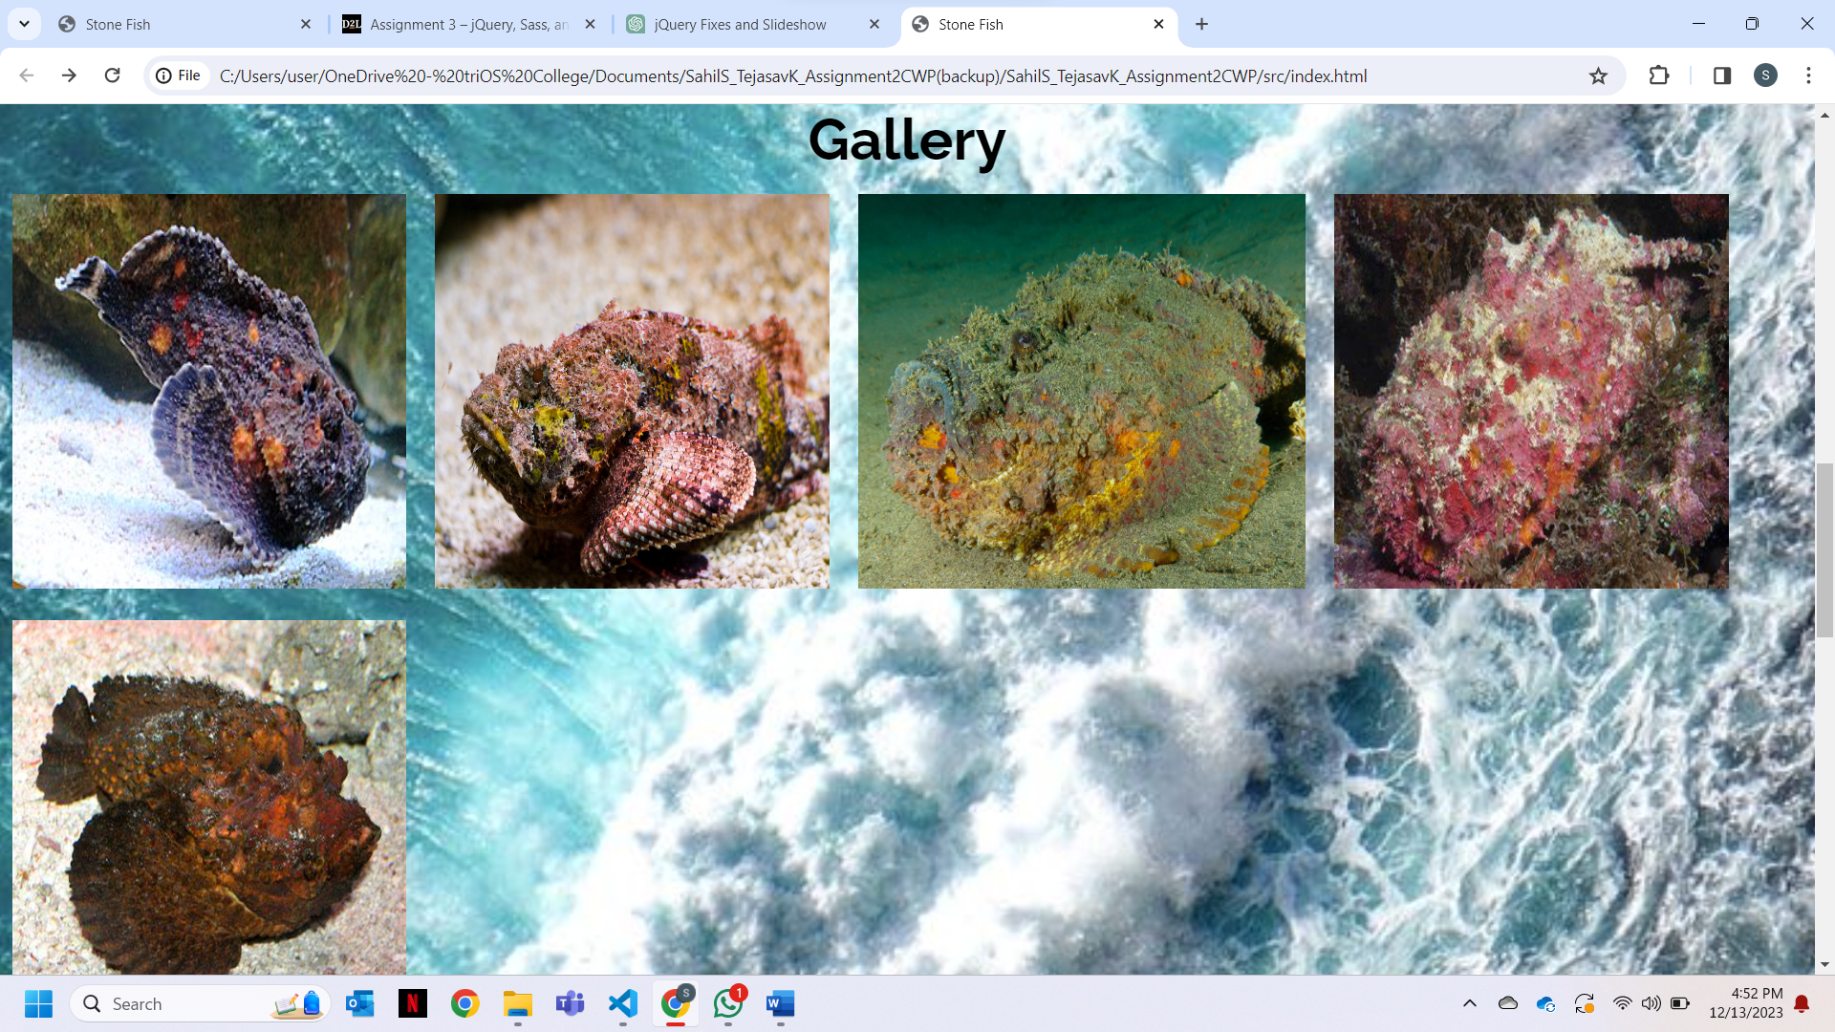

After: The images were played as a slideshow, and a click on either ‘Previous’ or ‘Next’ stops the slideshow.

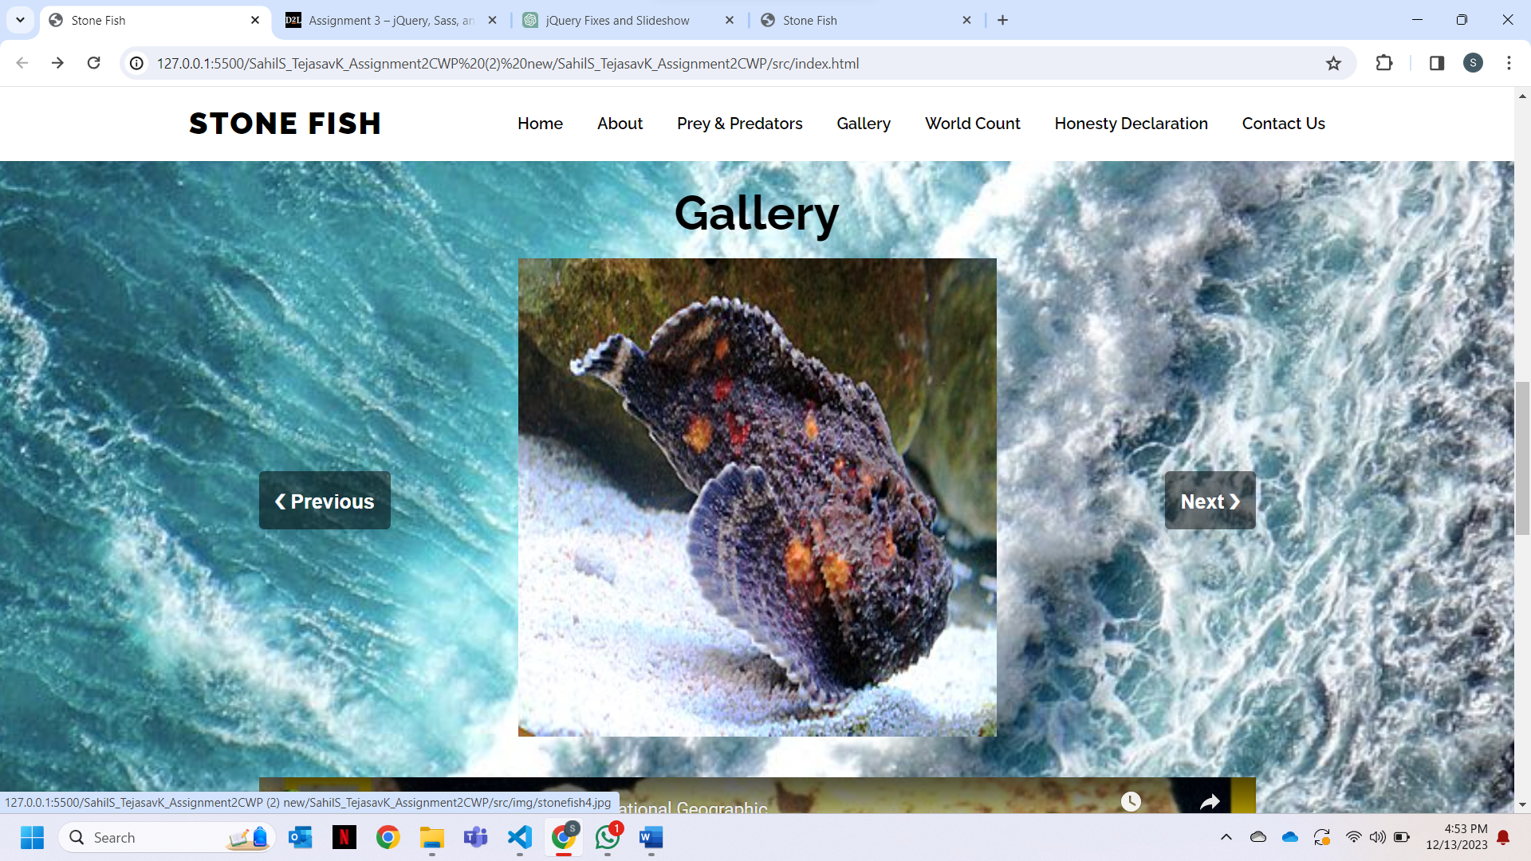

These were some of the changes that were applied to the previous document to enhance its working and functionality and to make it look more professional.